Health Department Reportable Diseases
COVID-19
Quick Start Guide
COVID-19, Flu and RSV records are reportable within 24 hours after being diagnosed.

Once you are logged into ERS and have clicked New Event, you will be brought to the Event Report page. Note: There are mandatory fields that are part of the ERS system on this page that don’t relate to COVID-19.

The first three are as follows: If you are entering multiple records, the Resident ID would not be appropriate. The suggestion is to enter covid, but anything would be accepted here.
The Date of Event should be the day you are entering the records and the Time of Event can be the actual time of entry.

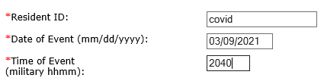

Health Department Reportable Diseases (Covid-19) – If you select Event Type = Health Department Reportable Diseases and Event-Sub-type = Covid-19, the Reportable Disease Detail section will appear. You will be required to add at least one Reportable Disease Detail record before submitting the event to DOH. There are two ways to enter information. It should be noted that both methods can be used during the same event. You can manually enter data and/or upload a spreadsheet/s.
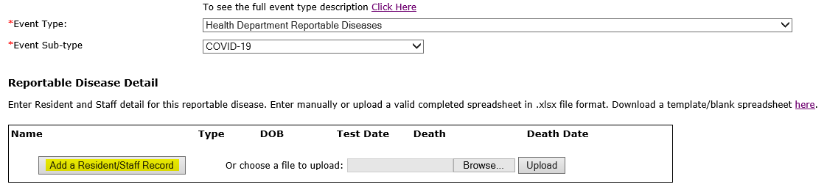

To add a record or records to the ERS Event:
- Click on the Add a Resident/Staff Record button. This will bring up the Resident/Staff Detail box. Multiple records can be added using the Add a Resident/Staff Record button.
If a previously submitted record needs to be corrected or updated, i.e., with a date of death, DO NOT add the correction or update as a new record. Instead, contact your field office to get the correction/update made. Please provide the Event ID with your request.
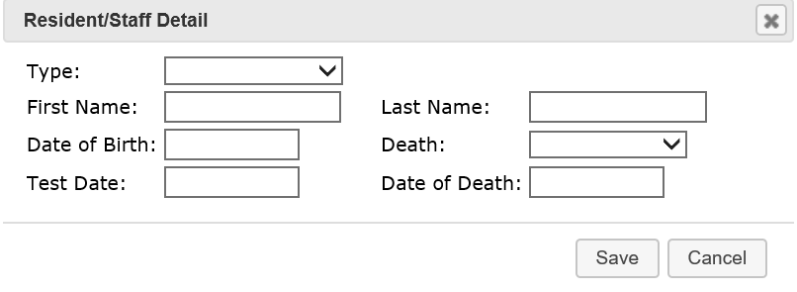
All fields except Death and Date of Death are required. All dates should be in the format: mm/dd/yyyy
For the privacy of staff, some facilities are using a numeric identifier.

Type drop down selection is either Resident or Staff
First Name of Staff or Resident
Last Name of Staff or Resident
Date of Birth of Staff or Resident
Covid-19 Test Date
Death – To record a patient or staff death, select the appropriate entry from the Death dropdown box. Note: Yes – Home refers to an individual’s personal home.
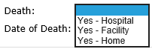
Date of Death – If Yes is selected in the Death field, Date of Death is required.

- Enter multiple records into a spreadsheet and upload the Reportable Disease Data. A spreadsheet is available for download. The maximum number of records that can be included on a spreadsheet is 999. Care should be taken that there are no blank lines in the spreadsheet. Only new data should be uploaded. If you are keeping a running spreadsheet for COVID, be sure that only new data is uploaded during each event. If a previously submitted record needs to be corrected or updated, DO NOT add the correction or update as a new record. Instead, contact your field office to get the correction/update made. Please provide the Event ID with your request.

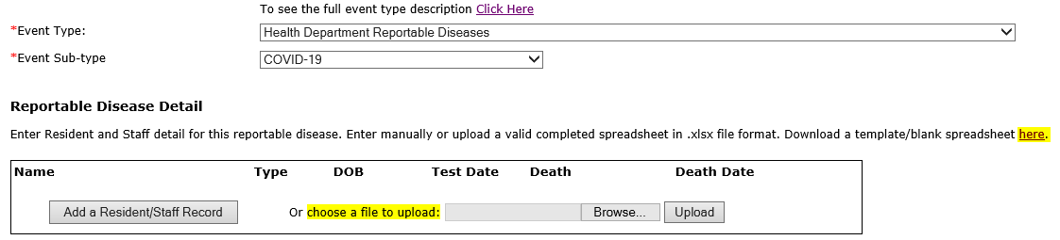
Get the spreadsheet template by clicking on the ‘here’ link
You can choose to Open or Save the template
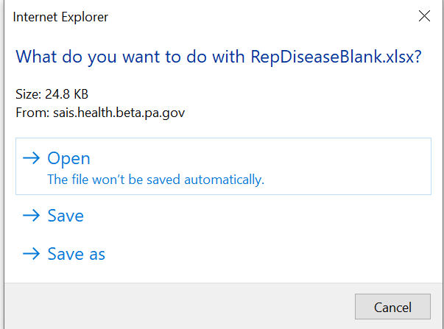

You will be able to add multiple Residents and/or Staff records and then save the spreadsheet with those entries. Multiple files can be uploaded in one event. There is a dropdown for column H, Death. The selections are Yes – Hospital, Yes – Facility or
Yes – Home (personal home).
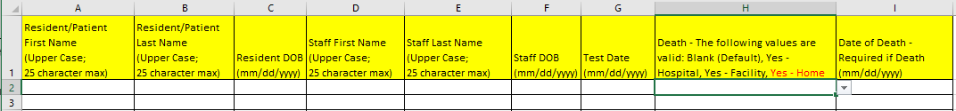

To upload the spreadsheet, click on the Browse button and locate the saved spreadsheet on your computer. Double click on the spreadsheet name or you can click on the name and then click Open. Either way, the spreadsheet will show in the window to the left of Browse. Next, click Upload.
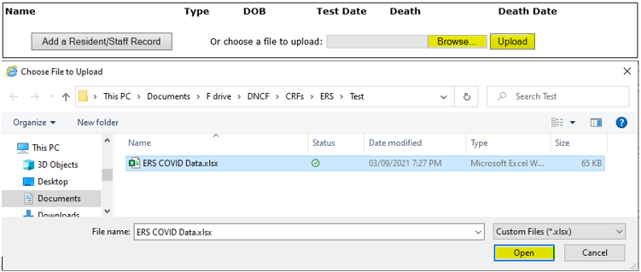

If you are adding records from multiple sources, you will get a message asking whether you want to Append to existing or Replace existing. This is referring to the information already added to this event and not records added to a previous event.

If you receive an error message after clicking on Upload, fix the spreadsheet, save it, and then select Browse again before selecting Upload.

If there is an exact duplicate in your spreadsheet, only the first record will load.

If you attempt to manually add an exact record that was already added to the current incident, you will receive the following message. Click OK and then either update the Resident/Staff Detail or click Cancel to close the window.
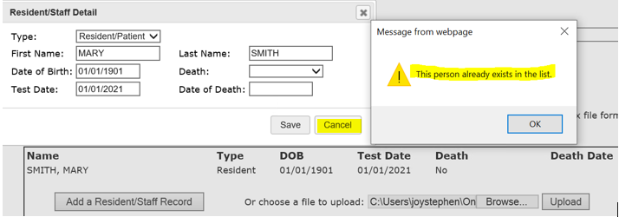

After uploading your records, you have the option to edit  or delete individual records prior to submission.
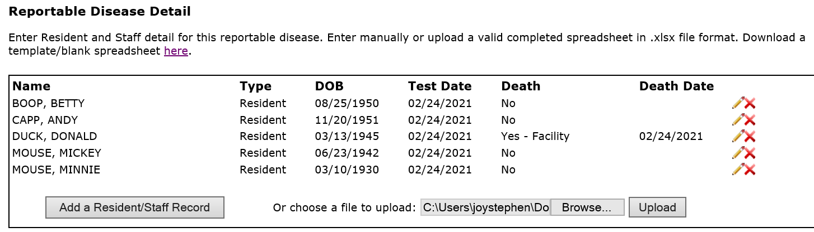

Complete the rest of the required fields. The suggestion is to enter facility/covid, but anything would be accepted for the Location of Event, Factual Description and Description of Follow-up Action.

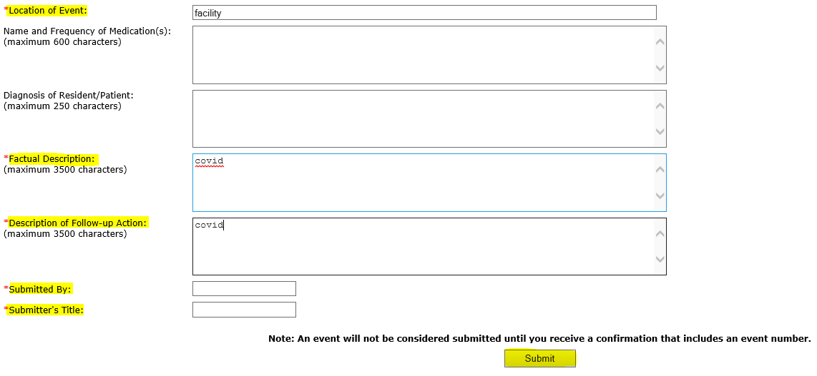
Submit the event for review by the field office.

Once an event has been submitted, if there are corrections that need to be made, they need to be made through your field office. If a resident/staff tests positive, only enter them once, unless 90 or more days have lapsed since the last positive test. In this case the resident/staff is to be counted positive again. If a resident/staff tests positive and then later expires, after the event is submitted, please contact your field office with the location and date of death so that the record can be updated. Please provide the Event ID with your request.

If you have any questions, please contact your field office for assistance.

